### PREDICTION OF MEAN SPECKLE CONTRAST VALUES OF DYNAMIC LASER SPECKLE IMAGING OF NEMATODE SUSPENSION USING MACHINE LEARNING TECHNIQUES

*A Capstone project report (CP302) submitted in partial fulfillment of the requirements for the award of the degree of*

##### Bachelor of Technology

*in*

##### Chemical Engineering

*by*

**Kadavath Akhil Rathod**

(Entry No. 2021CHB1364)

*Under the Supervision of*

**Dr. Vishwajeet Mehandia**

**(Associate professor)**



Department of Chemical Engineering

#### INDIAN INSTITUTE OF TECHNOLOGY ROPAR

**Punjab - 140001, India**

November, 2024

## **Acknowledgements**

I would like to express my sincere gratitude to my supervisor, **Dr. Vishwajeet Mehandia**, for their invaluable guidance, support, and encouragement throughout the course of my B. Tech project. Their expertise, patience, and mentorship have been instrumental in shaping the direction of this research and in my personal and academic growth. I am truly thankful for their unwavering dedication, insightful feedback, and constant motivation, which have been pivotal in navigating the challenges and complexities of this project.

Furthermore, I am grateful to my family and friends for their unwavering support, encouragement, and understanding throughout this endeavor. Their belief in my abilities and their encouragement has been a constant source of strength and inspiration.

Thank you to everyone who has contributed to the progress made on this B. Tech project up to this stage. Your support and guidance have been invaluable, and I am deeply grateful for the opportunity to undertake this research.

## **Abstract**

This study investigates the application of machine learning models to predict the mean speckle contrast values of speckle images of nematode suspension (vinegar eels) subjected to varying concentrations of antibacterial treatments. DLSI (dynamic laser speckle imaging) enables real-time organism growth and motility observation. In the case of nematode suspension, this technique can track the movement and proliferation of these organisms within their acidic environments. DLSI was employed to capture the microbial motility, with images processed using Fiji software for initial labelling of the images [input data] and Fourier transforms to extract frequency domain features from speckle data. Mean speckle intensity and contrast values of experimentally obtained speckle images can be obtained by applying image processing techniques in Fiji software. Regression models, including linear regression, decision trees, random forests, and artificial neural networks (ANN), as well as 3D CNN, were used to analyse and predict the mean speckle contrast over time [continuous data]. The study aims to evaluate microbial motility, health, and response to treatment using these predictive models. The performance of the models was compared using metrics such as mean squared error (MSE). The regression models and deep learning models demonstrate superior predictive capabilities, offering insights into the potential for integrating speckle imaging with machine learning in biological research.

# Contents

**Acknowledgements**

**Abstract**

**Contents**

1. Introduction . . . . . . . . . . . . . . . . . . . . . . . . . . . . . . …………. 6
   1. Problem Statement . . . . . . . . . . . . . . . . . . . . . . . 7
   2. Need of the Study . . . . . . . . . . . . . . . . . . . . . . . . 7
   3. Study Objective . . . . . . . . . . . . . . . . . . . . . . . . . 7
2. Literature Review . . . . . . . . . . . . . . . . . . . . . . . . . ……………8
   1. Overview & Applications . . . . . . . . . . . . . . . . . . . . . . . . . . …..8
   2. Machine Learning Approaches for Prediction . . . . . . . . 10
   3. Challenges and Future Directions . . . . . . ... . . . . . . . 11

3. Methodology . . . . . . . . . . . . . . . . . . . . . . . . . . . . . ………………..12

* 1. Machine Learning Implementation with EDA. . . . .. . . . .18
     1. Data preprocessing & Feature Engineering. . . . .18
     2. Artificial Neural network ... . . . . . .. . . . . . .20
     3. Results and Plots for ANN. . . . . . . . . . . . . . . . . . .21
     4. 3-D Convolutional Nueral Network . . . . . . . .32
     5. Results and Plots for CNN . . . . . . . . . . . . . . . . . . . . .35

4. Results . . . . . . . . . . . . . . . . . . . . . . . . . . . . . . . . . . ……………...41

5.Conclusion . . . . . . . . . . . . . . . . . . . . . . . . . . . . . . . ……………….43

1. References . . . . . . . . . . . . . . . . . . . . . . . . . . . . . . . ……………….43

### Introduction

Mean intensity and contrast values derived from speckle images play a crucial role in monitoring the activity of microorganisms, such as assessing microbial viability and evaluating the health of their ecosystems. Changes in microbial viability in response to antibiotics can also be studied by analysing bacterial attributes such as shape, motion, size/mass, or respiration/redox states.

The ***Vinegar eel*** is a free-living nematode that thrives in fermentation byproducts and feeds on bacteria. Historically, it was commonly found in commercial vinegar. Adapted to acidic environments, these nematodes are also found in acidic lakes. To analyse their activity, various optical methods can be employed to assess changes in shape, length, and motion visually[1]. A simpler and cost-effective approach involves measuring light attenuation scattered off organism populations, eliminating the need for complex optical setups. One such technique is **laser scattering**, which underpins **Dynamic Laser Speckle Imaging (DLSI)** and **Rapid Antibacterial Susceptibility Testing (RAST)[2]**.

A laser speckle is an interference phenomenon observed when coherent light irradiates a rough surface or propagates through a medium containing scattering particles. Speckle images exhibit unique texture patterns influenced by scatterers and contrast changes due to motion, such as nematode cluster formation or particle dynamics. When light waves arrive with opposite phases, their amplitudes cancel out, producing dark spots. Conversely, constructive interference leads to bright spots. This random distribution of bright and dark areas forms the **laser speckle pattern [3]**. When the illuminated surface or scatterers (e.g., nematodes in suspension) move, the speckle intensity fluctuates randomly, generating a time-varying speckle pattern. Faster-moving scatterers result in higher-frequency fluctuations, while slower scatterers produce lower frequencies. Dynamic laser speckle directly influences contrast, and changes in speckle patterns over time can be quantified using image processingtechniques like ImageJ (FIJI) or OpenCV. In this study, we employ spatio-temporal contrast analysis, where the dynamics of each pixel within a specified Region of Interest (ROI) are determined using advanced image processing.

Dynamic Laser Speckle Imaging (DLSI) is particularly effective for analysing biological activity, such as the movement of particles (e.g., nematode worms) in suspension at varying concentrations[3]. DLSI provides visualization and information of the optical density (OD) and intensities of speckle images at each time instant (from t=0 to t=90 minutes) under different concentrations-C_1 (9.04% v/v), C_2 (4.52% v/v), C_3 (2.26% v/v), and C_4​ (1.13% v/v). These suspensions, typically acidic, have concentrations determined by their pH values.

By employing this technique, we can assess speckle contrast changes over time and link them to microbial activity, paving the way for innovative applications in microbiology and ecosystem health monitoring.

#### Problem Statement

Microbial motility is a critical aspect of many biological processes such as nutrient uptake, biofilm formation, and the spread of infections. Traditional methods like RAST (Rapid antibacterial susceptibility testing) of assessing bacterial motility are manual and time-consuming, limiting their effectiveness for real-time applications. RAST methods are of significant importance in healthcare, as they can assist caregivers in timely administration of the correct treatments. Various RAST techniques have been reported for tracking bacterial phenotypes, including size, shape, motion, and redox state. However, they still require bulky and expensive instruments, which hinder their application in resource-limited environments and/or utilize labelling reagents which can interfere with antibiotics and add to the total cost. Dynamic laser speckle imaging (DLSI) provides a powerful tool for studying the motility of organisms, specifically in relation to changes in their environment. Given its versatility, LSCI has been extensively utilized in both preclinical research and clinical settings, playing a crucial role in determining disease status and evaluating treatment effectiveness. In this study, we aim to predict **Mean** **speckle contrast** changes over time (i.e. t = 0 to t = 90 min) of speckle image data of nematode under the influence of varying their concentrations using **Machine Learning models**. This can offer insights into microbial health and responses to treatment, which is critical for applications in healthcare and environmental monitoring.

#### Need of the Study

There is a growing need for non-invasive techniques to assess organisms’ activity and ecosystem health, particularly in the context of developing internal particle dynamics and antibiotic resistance. Laser speckle contrast imaging (LSCI) has established itself as a valuable tool for non-invasively assessing the biological activity of the nematode cluster movements. Speckle imaging offers a unique method for observing changes in microorganism motility and health, but the complexity of speckle patterns requires robust analysis techniques. Machine learning models provide an innovative approach to extracting meaningful patterns and conclusions from speckle images, thus enhancing our understanding of organism’s dynamics.

#### Study Objective

The primary objective of this study is to develop machine learning models capable of predicting mean contrast values from DLSI images. Initial labelling [Y = Predictions: Mean contrast for speckle images] can be obtained by image processing in FIJI software to train our ML model. These predictions will enable us to:

* Study microbial motility and activity in response to different acidic environment.
* Evaluate the overall health of bacterial ecosystems within the vinegar eels(nematodes).
* Accessing speckle contrast changes over time and linking them to microbial activity, paving the way for innovative applications in microbiology and ecosystem health monitoring.

### Literature Review

#### Overview and Applications

Mean speckle contrast of DLSI is sensitive to motion within a sample. In the case of nematode suspensions, varying concentrations and activity levels will cause differences in speckle contrast due to changes in particle motion and interaction. By analyzing the temporal changes in mean speckle contrast from t=0 to t=90 min, you can characterize the dynamics of the nematode suspension. For example, an increase in mean contrast might indicate decreased motion (aggregation or quiescence), while a decrease might suggest increased activity. Applications extend to medical diagnostics, food safety, and environmental monitoring, where understanding bacterial behavior can lead to better management of contamination, disease, or antibiotic resistance. A time series of these dynamic speckle images contains information about particles kinetic behavior and can be used as a means to probe the effect of environmental triggers, including antibiotics, on their motion. Hence, in the case of nematode suspension environment, this technique can track the movement and proliferation of these organisms within their acidic environments.

**Interpreting Dynamic Speckle Images**:

1. Active Zones Identification (Intensity Zones of nematode clusters): Areas with intense speckle activity indicate regions where organisms are actively growing or moving. By analyzing these patterns, one can determine the spatial distribution of their activity within the petri dish.
2. Growth Rate Estimation: The temporal evolution of speckle patterns can be correlated with organism growth rates. An increase in speckle intensity over time suggests active proliferation, while a decrease may indicate a cessation of growth or bacterial death.
3. Position of Cluster Formation: Based on the mean intensity values obtained from the speckle images at the centre and corner, we can find the grouping of the organisms (Cluster) uniformly distributed at either the centre or corner.

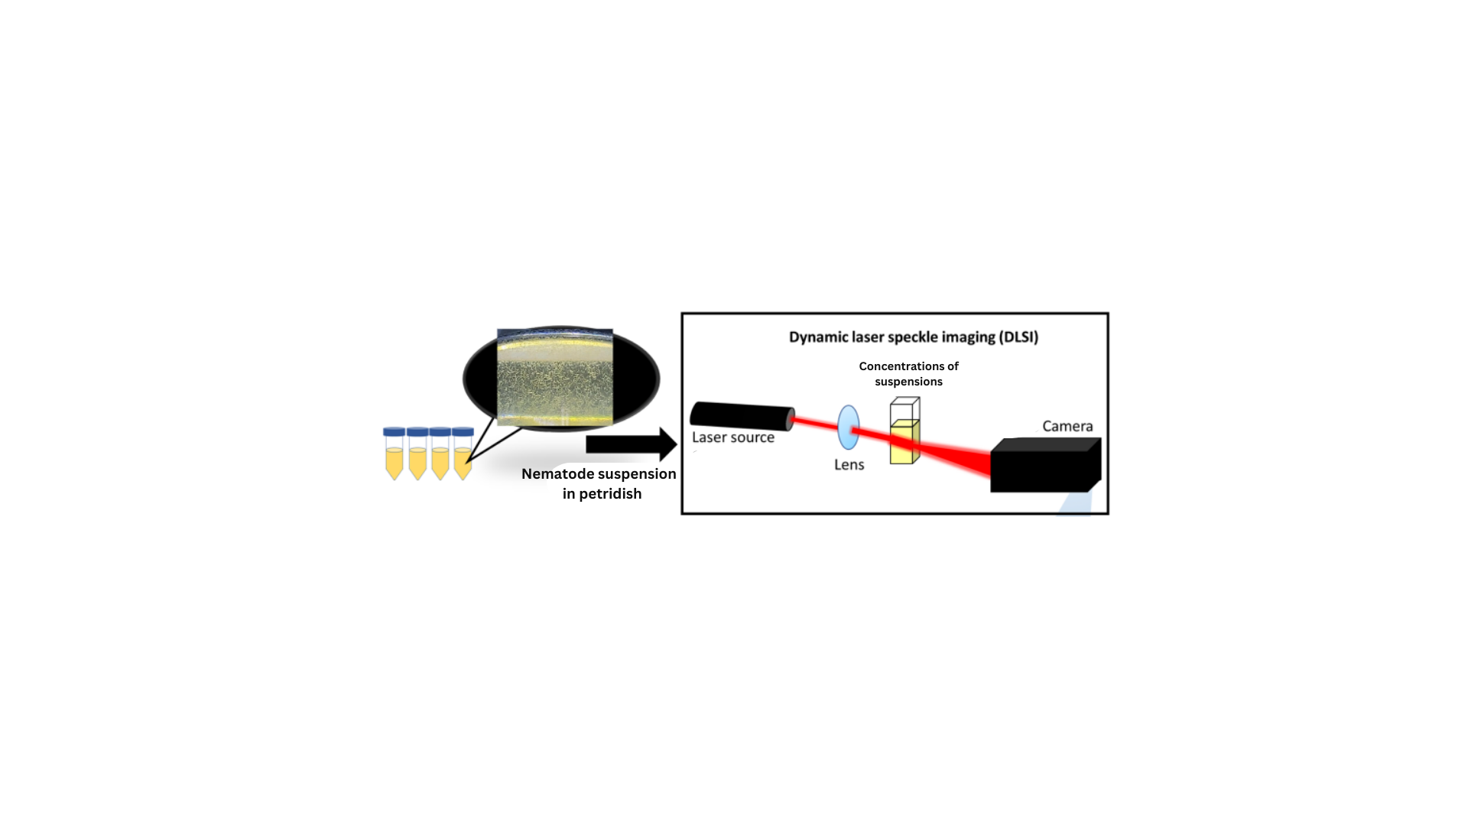

**Figure 1: The workflow (Flowsheet) for the DLSI processes involved till now.**

The Raw camera image of the bacterial image captured by the High-speed camera is in Figure 2.1, and its processed image in FIJI software is in Figure 2.2.

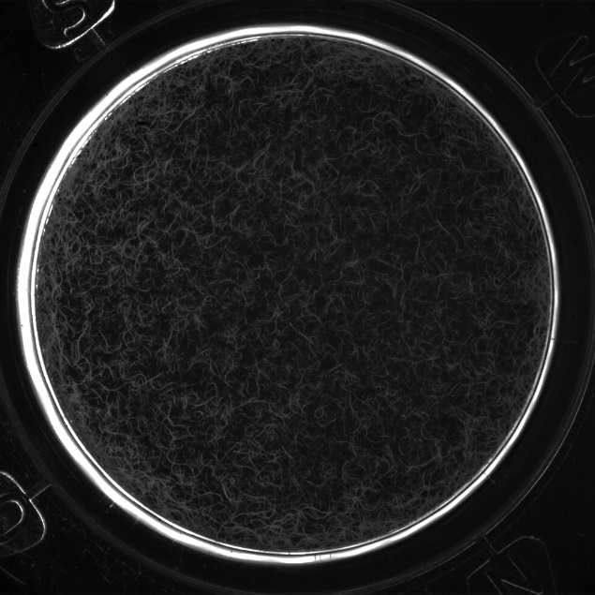

Figure 2.1 Raw camera image sample from C_3 Figure 2.2 Processed image of Fig2.1 in FIJI Software.

concentration at time t = 3 min.

In Figure 2.2, we can see that the worms are visible as white granular structures and the remaining black surface is the emptiest space in the petri dish environment. We can draw insights such as concentration of worms (number of worms) in the petri dish at each time instant by using FIJI software. Fiji is a distribution of the popular open-source software ImageJ focused on biological image analysis. Fiji uses modern software engineering practices to combine powerful software libraries with a broad range of scripting languages to enable rapid prototyping of image processing algorithms.

We use this software and its plugins to analyze the concentration of worms in preprocessed images such as shown in fig 2.2 and mean speckle contrast at center and corner by for the speckle images by taking constant ROI (Regions of Interest) values for center and corner same. The Regions of Interest (ROI) method in Fiji (ImageJ) is a tool for manually annotating and measuring images. It can be used for many applications, including Quantifying intensity bands at specific areas of the images. We took ROI of 10x10 pixel values for all speckles to gather information on the mean intensities at the centre and corner. Through this, we can gather how intensity and contrast values behave at the corner and centre relative to the time at a particular concentration. Most importantly, this software is used here to label the input data (Processed images of camera images) to train the ML model in predicting the values of mean intensity (Output).

* 1. **Machine Learning Approaches for Mean Contrast Prediction.**

In recent years, machine learning has emerged as a key tool in biological studies, with applications ranging from the prediction of gene expression patterns to the analysis of microbial motility. Traditional regression models, such as Multiple Linear Regression, Decision Trees, and Random Forest, have been widely used in biological studies to predict continuous variables. However, as datasets become more complex, DL models like 3D Convolution Neural network (3D CNN) and Artificial Neural Networks (ANN) have gained popularity due to their ability to model non-linear relationships and process high-dimensional data [4].

The flowsheet for the overview of the project is shown in Figure 3.

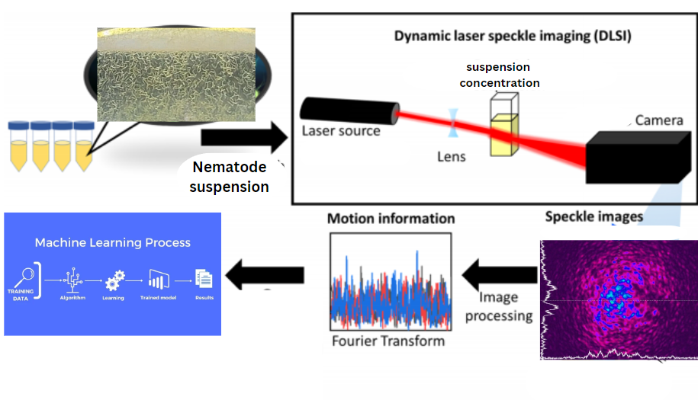

**Figure 3 Schematic of the work flow involved till now**.

The flexibility of Deep learning models allows for the capture of non-linear relationships in the data, improving the accuracy of these predictions. For training the ML model, we use the mean contrast values obtained initially from the FIJI software (image preprocessing) for the corresponding Xi’s. By this, we can test these models on the test set (Unseen data samples of Xi’s).

We split the input data Xi’s (FT speckle images), including their labelling (Yi’s – mean intensities obtained from FIJI software) into the Train set and Test set in the 80: 20 Ratio, respectively. The train set is used to train the ML model, where the machine typically learns and tests the set, where the machine implements the learned information (pattern, logic, etc.) from the trained set and makes predictions on this unseen data.

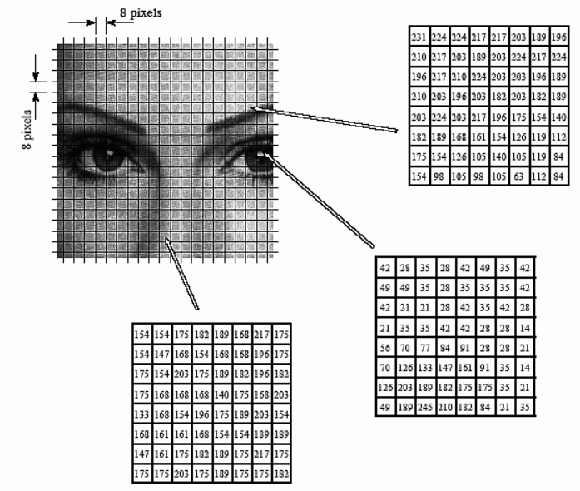

**Figure 4 Visual representation of Fourier transformation of the image that is used to convert the spatial domain into frequency domain of features based on the ROI (Region of the interest) of the image.**

As we can see from Fig 4, the data in the matrix represents the information about the frequency domain in the form of matrices. This matrix is fed as input data in the form of 1 1-dimensional input array into the ML model.

#### Challenges and Future Directions.

Challenges in this field include handling noisy data and the need for robust preprocessing techniques, such as Fourier transforms, to manage frequency domain information effectively. The interpretation of model results in biological contexts adds another layer of complexity, as does the risk of overfitting and the high computational load associated with high-dimensional input data.

A significant challenge in utilizing Dynamic Laser Speckle Imaging (DLSI) data for microbial motility studies is the intricate nature of speckle patterns, which are often affected by noise, lighting variations, and the resolution of the imaging setup. Additionally, calibrating models across diverse environments remains a critical hurdle to achieving consistent and reliable predictions.

Future research directions could prioritize improving the interpretability of models and integrating speckle image analysis with real-time biological monitoring systems. Another promising avenue involves leveraging deep learning techniques to enhance predictive accuracy, especially for complex biological datasets. Driven by the growing interest in applying machine learning technologies to medical image processing, researchers have increasingly explored the integration of these techniques into LSCI analysis.

Researchers can utilize mean speckle contrast as a foundational metric to develop innovative approaches for analysing intricate systems, fostering advancements in optical measurement techniques. Beyond nematode studies, the insights gained from mean speckle contrast are broadly applicable to fields such as microfluidics, materials science, and medical imaging, including applications in blood flow and tissue analysis.

### Methodology

This section provides an overview of the input data analysis, Feature engineering, Machine learning models and preprocessing techniques used in the study, starting with image preprocessing using Fourier transforms and extending through model training and validation.

We have atmost three sets (i.e. set1, set2 & set3) of experimental data of speckle images at every concentration including center and corner. Taking the mean of multiple experimental runs before doing feature engineering is a common practice and has specific advantages. By taking mean, there are chances of reducing random noises, outliers in the speckle image data by improving data consistency. For 3 sets of Xi’s there would be same set of target variables (**Yi mean’s = sum (Yi’s from set 1, set 2 & set3)/3**).

**Image Processing:**

The result obtained during the image preprocessing in FIJI, gives insights on the mean contrast behaviour of center and corner speckle images with respect to time. Also, the concentration of worms in the camera images can also be analyzed by preprocessing it in FIJI software by running the macros scripts. The following graph plots will provide the brief results on the mean contrast relative to the time samples of the input data for corner and center speckle images. Also, the concentration vs time sample graph also talks about how organisms are growing/decaying with time by measuring their concentrations at each time instant.

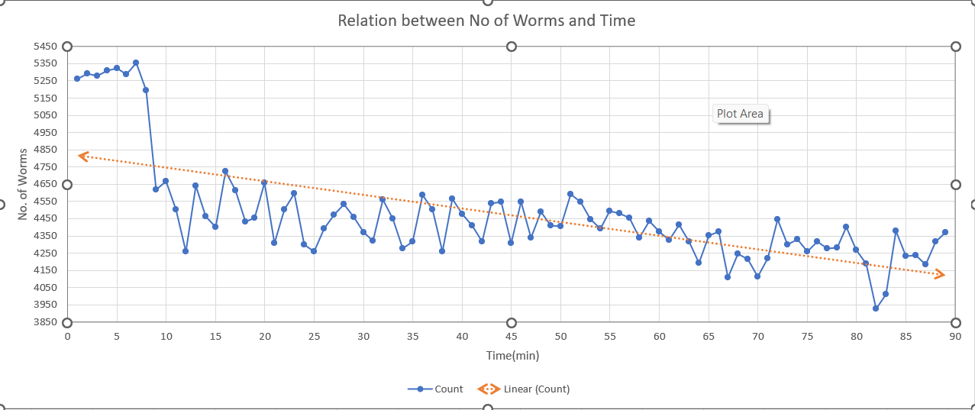

**Result for the concentration of worms (nematode suspension) at set 1 C_3(2.26%w/w) vs time for raw camera images:** Inverse relation with time tells that organisms are not producing/increasing as time progresses.

**Data Visualization of Mean Speckle contrast behaviour for Center speckle images for all concentrations:** Inverse relational with time tells that Speckle contrast for the speckle images decreases as time progresses at the center area (center of the petri dish based on ROI taken). We can draw the following insights for this behavior:

1. **Increased Motion or Activity:** Speckle contrast (K=σi/⟨I⟩) is inversely related to the motion of scattering particles. A decrease in speckle contrast implies an increase in the activity or motion of nematodes, possibly due to:
2. **Stimuli Response**: Nematodes react to a stimulus (e.g., heat, light, or chemical exposure).
3. **Increased Dispersal**: Enhanced motility, causing a more dynamic suspension.

**2. Homogenization of the Suspension:** As nematodes move more, the suspension becomes more uniform in its scattering properties, leading to reduced contrast. This indicates:

* **Reduced Clustering**: Nematodes are spreading out rather than forming aggregates.
* **Active Mixing**: Enhanced fluid flow caused by nematode motion.

**3. Reduced Scattering Effects:** If individual nematodes or suspended particles are scattering light more dynamically, temporal fluctuations in intensity reduce, lowering the contrast:

* **Dominance of Dynamic Scattering**: Over static scatterers, caused by increased movement or reduced static elements.

**4. Physiological or Environmental Influence:** External factors or physiological changes could be driving this behaviour:

* **Energetic Burst**: A high activity phase due to favourable environmental conditions.
* **Stress or Stimulation**: Possibly induced by external factors affecting motility.

**5. Potential Systematic Issues:** If unrelated to biological dynamics, decreasing contrast might signal:

* **Instrumentation Factors**: Issues like increasing exposure time or changes in imaging setup.
* **Environmental Disturbances**: External vibrations or flow in the suspension.

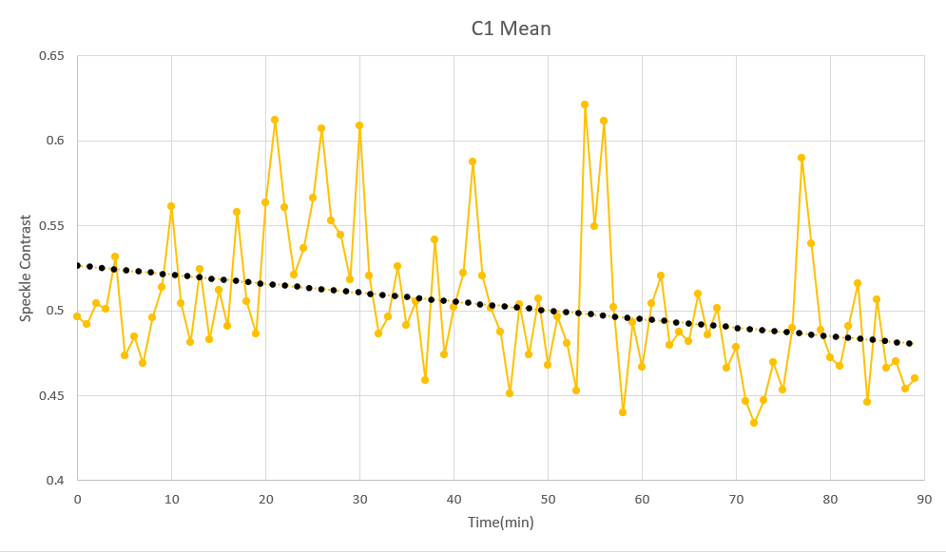

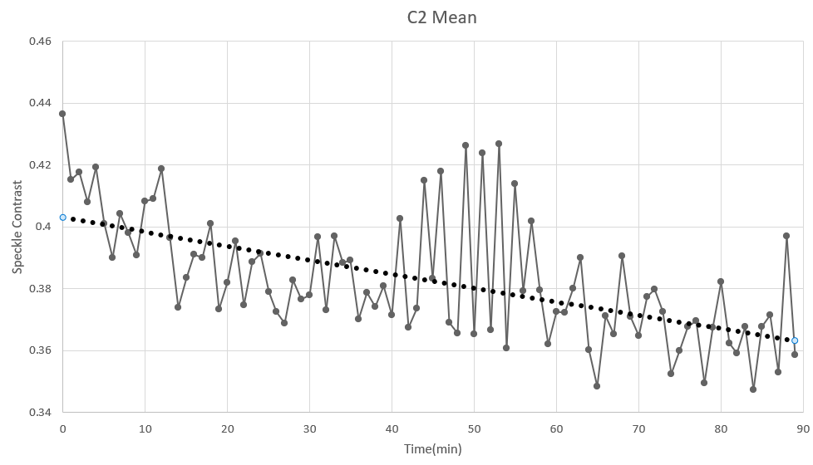

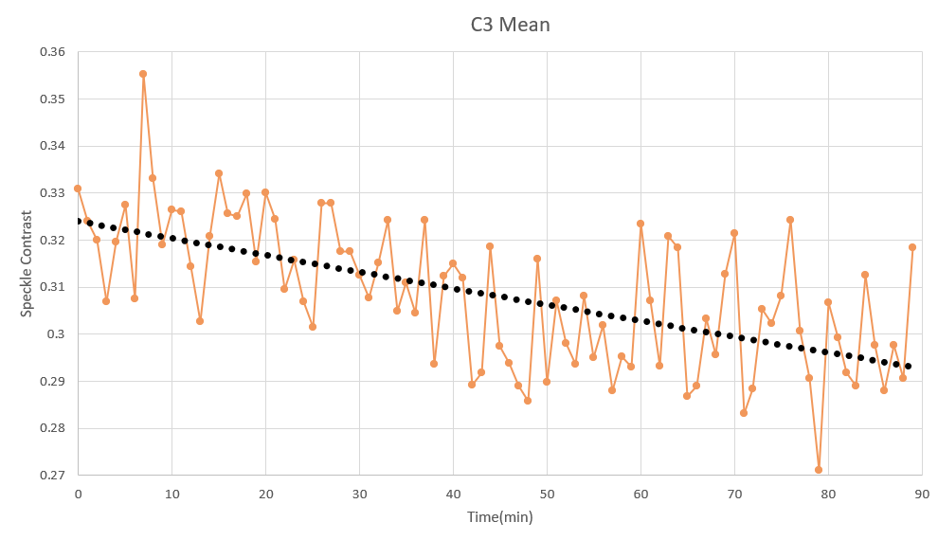

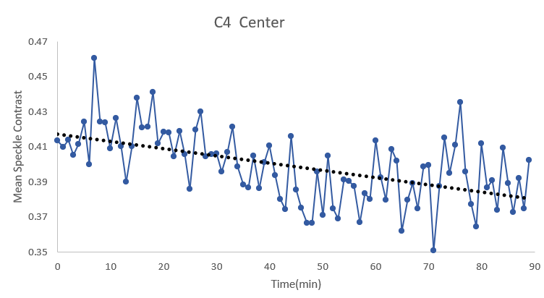

**Data Visualization of Mean Speckle contrast behaviour for Corner speckle images for all concentrations:** Proportional relational (except C3) with time tells that Speckle contrast for the speckle images increases as time progresses at the corner area (Random corner area of the petri dish based on ROI taken). Here we assume that at every time instant there would be uniform distribution of organisms(worms) over the circumference of the petri dish initially so that, we can take ROI at any corner area we want. Hence based on this assumption, we able to calculate the mean speckle contrast values for every corner speckle images in FIJI software. We can draw the following insights for this behaviour:

**Reduced Motion or Activity:**

* In the corner area, this might imply that nematodes are becoming less active, aggregating, or entering a quiescent state due to environmental factors like oxygen depletion, light exposure, or crowding.

**Static Scatterer Dominance**:

* The presence of more static scatterers (e.g., sedimentation of nematodes or particulate matter) in the corner area could lead to a higher speckle contrast.
* Static scatterers produce higher contrast because of their consistent intensity pattern over time.

**Spatial Variation in Dynamics**:

* The corners might represent areas of lower flow or reduced mixing in the suspension, causing nematodes to settle or exhibit less movement. This spatial heterogeneity could result in a localized contrast increase.

**Boundary Effects**:

* Boundaries or walls of the container holding the suspension can lead to unique interactions, such as reduced mobility or confinement effects, increasing speckle contrast in those regions.

**Biological Implications:**

**Concentration Gradients**: Higher local nematode concentrations near the corners could contribute to reduced overall movement, enhancing speckle contrast.

**Environmental Constraints**: Changes in temperature, light, or chemical gradients near the corners could explain reduced nematode activity.

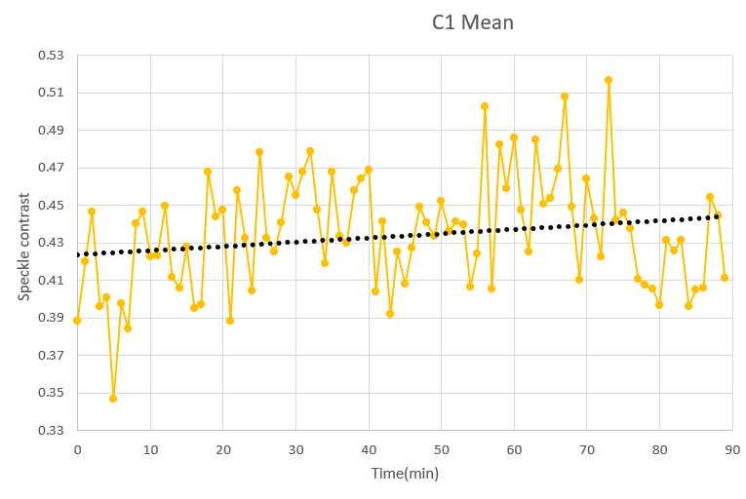

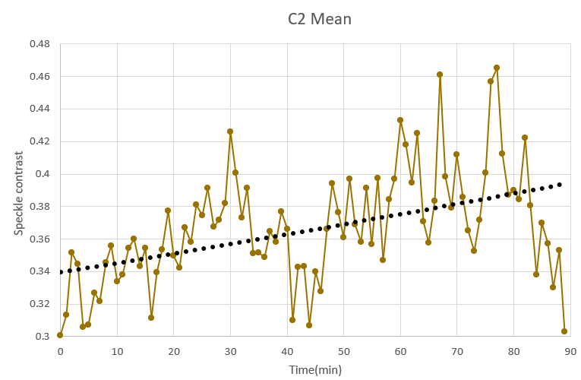

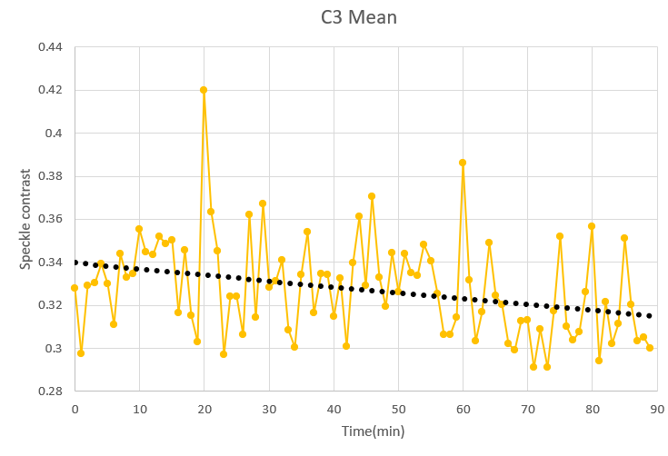

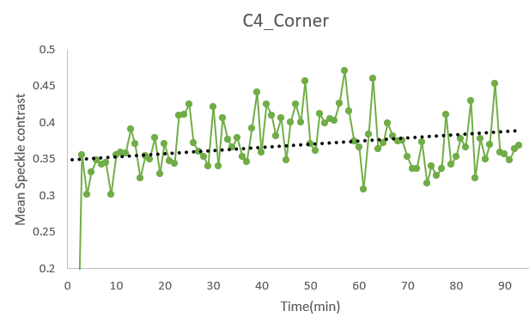

#### Machine Learning Implementation

#### Data Preprocessing and Feature Engineering.

Knowing that speckle contrast is a crucial factor, we are focusing on extracting contrast-related features from images like pixel intensity distributions or derived contrast metrics. These are used as input for ML models. **Fast Fourier Transform** (FFT) or similar transformations for feature extraction, turning each image into a manageable array representing frequency-domain characteristics**.** FT (Fast Fourier Transform) is part of the feature engineering process. It is a mathematical operation that transforms an image from its spatial representation to its frequency-domain representation. This transformation acts as a step-in feature extraction, which is a subset of feature engineering. Speckle images are converted into the frequency domain using FFT, capturing patterns and variations that may not be evident in the spatial domain. Although FFT often increases initial data dimensionality, you can selectively focus on significant frequency components, ignoring less relevant ones, effectively reducing the feature set. ANN models use FFT-transformed data because frequency-domain features often carry meaningful and less noisy information about the system being studied. In 3D CNN, no FFT is used. Instead, pooling and batch normalization work well in CNN, which are built to extract the features directly from speckle images. So, speckle images are directly fed into the 3D CNN model as input.

The resultant frequency data were then flattened and normalized for use as input features in machine learning models and ANN for regression tasks. Applying FFT on the speckle images extracts frequency features and analyzes the magnitude spectrum of these features to identify patterns that correlate with the speckle intensity and contrast values. Hence, by using FFT (Fast Fourier Transform), we can transform the spatial data present into the frequency domain. This frequency domain for every speckle image will be the input data for the ML model. We fed these frequency domains for each speckle in the form of input vectors (1-D vectors of frequency domain or feature array) into the ML model for predicting the mean speckle contrast (Yi) of the corresponding input sample (Xi = input speckle image sample at i-th time instant). So, basically this becomes now a regression model in predicting Yi’s from Xi’s.

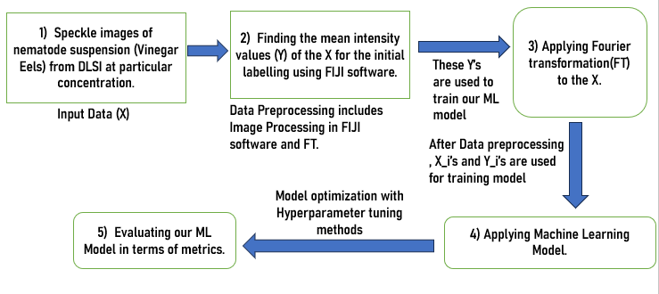

Figure Machine Learning Pipeline.

|  |  |  |  |
| --- | --- | --- | --- |
| **Table 1: Machine Learning Overview** | | | |
| **Model** | **Input Data** | **Preprocessing** | **Final Input Shape** |
| ANN and other regression models | Frequency-domain (FFT) data | FFT, flattening, feature scaling | (n_samples, n_features) |
| 3D-CNN | Spatial-domain Speckle image data | Resizing, normalization, channel add | (n_samples, height, width, channels) |

After FFT, the features (n_features) are large in number will leads to high dimensional data. This High dimensional data increases computational load and complexity. Dimensionality reduction techniques such as PCA (Principal Component analysis), LDA (Linear Discriminant Analysis) can reduce the features in the data but we end up in loosing important features.

To overcome this problem, **motion features** for a sequence of image frames. It extracts meaningful temporal features by computing changes between consecutive frames, which helps capture the dynamics of the system being studied. It gives Outputs as a matrix where each row contains [mean_change, std_change, max_change, energy_change] for the corresponding frame difference. **Motion feature extraction** does the following tasks:

* **Capturing Temporal Dynamics:** Motion features provide a summary of how the image content evolves over time, which is essential for applications where temporal patterns are critical, such as:
  1. Analyzing biological processes.
  2. Tracking motion or movement patterns.
  3. Identifying transitions or anomalies in temporal data.
* **Enhancing Model Inputs:** These features serve as an additional set of input data alongside static image features, enabling the model to account for both spatial and temporal information.
* **Simplified Modeling:** By reducing frame-by-frame data into summary statistics, the model can focus on key temporal aspects without needing to process raw frame differences directly.

• Avoiding **Overfitting:** Reducing dimensionality mitigates the risk of overfitting, especially when working with limited data.

• Efficiency**:** Smaller input data enables faster training and inference.

Shape Inputs (Xi’s) are (n_frames, 4), where n_frames represents the number of samples for training the model after reducing the FFT transformed features.

* **Mean change (X1)**: Average magnitude of changes in pixel values.
* **Std change (X2)**: Variability in pixel value changes.
* **Max change (X3)**: Largest single pixel change, highlighting extreme motion.
* **Energy change (X4)**: Sum of squared changes, emphasizing the magnitude of the overall motion.

#### Artificial Neural Networks (ANN)

The ANN model was designed with multiple layers to capture non-linear relationships in the data. Grayscale speckle images were resized to 924x689 pixels. Fourier Transform (FFT) was applied to convert the spatial data into the frequency domain. The magnitude spectrum of the FFT was flattened for input features. The model uses optimal activation function obtained by hyperparameter tuning methods for the hidden layers and a linear activation for the output layer to predict continuous values (Regression layer Activation function). The network has to train for optimal number of epochs (complete pass of the training data through the learning algorithm, also known as a training cycle) with an optimal optimizer (function or an algorithm that adjusts the attributes of the neural network, such as weights and learning rates) obtained from the GridsearchCV. By tuning our ML model with these Hyperparameter tuning methods can able to reduce the loss function.

**Hyperparameter Optimization**:

* Employed GridSearchCV with scikit-learn’s Keras to tune hyperparameters, including:
  1. Number of neurons in hidden layers.
  2. Batch size and number of epochs.
  3. Learning rates and optimizers (SGD, Adam, etc.).
* Evaluated models using cross-validation and selected the configuration with the best performance metrics. The **Adam optimizer** ensures efficient weight updates during backpropagation.

Generally, MSE would be the loss function. Model performance was visualized by plotting training and validation loss over time.

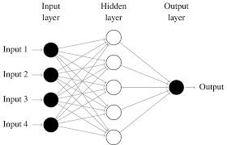

**Figure 6**: Visual representation of ANN structure with 4 neurons as Input layer and 1 output Yi as Mean contrast value for that sample. ( https://www.researchgate.net/figure/Simple-feedforward-neural-network-with-four-features-inputs-one-hidden-layer-and-one_fig1_359505982)

#### Results and plots for ANN:

#### The results of ANN are presented below as the 1) Scatter plots and 2) Regression plots for Actual vs Predicted values for every set of input images as mentioned in the second and third tables. (i.e. 8 sets for corner and center)

#### Scatter Plot Results for Center speckle images: If the red and blue dot coincides, then it represents that, predicted value of mean speckle contrast (Yi pred) for the image in the test set is equal to its actual value (Yi).

#### 

**Figure 7**: C1 set1

#### 

**Figure 8**: C1 set2

#### 

**Figure 9** : C2 set 1

#### 

**Figure 10**: C2 set 3

#### 

**Figure 11:** C3 set1

#### 

**Figure 12:** C3 set3

#### 

**Figure 13**: C4 set1

#### 

**Figure 14**: C4 set3

#### Additional Scatter Plot with Regression fit Results for Center speckle images: The figure contains the performance metrics like MSE (Mean squared Error) along with MAE (Mean Absolute error).

#### 

Figure C1 set1

#### 

Figure C1 set2

#### 

Figure C2 set1

#### 

Figure C2 set3

#### 

Figure C3 set1

#### 

Figure C3 set 3

#### 

Figure C4 set1

#### 

Figure C4 set3

**Scatter Plot Results for Corner speckle images:**

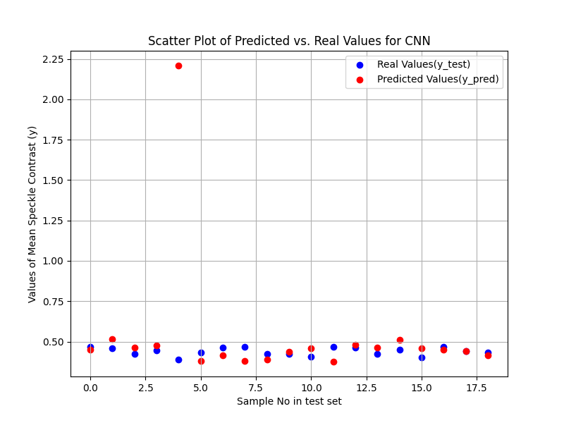

Figure C1 set1

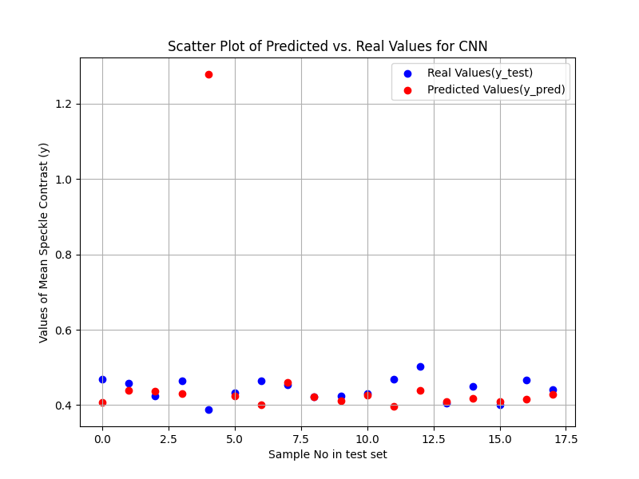

Figure C1 set 3

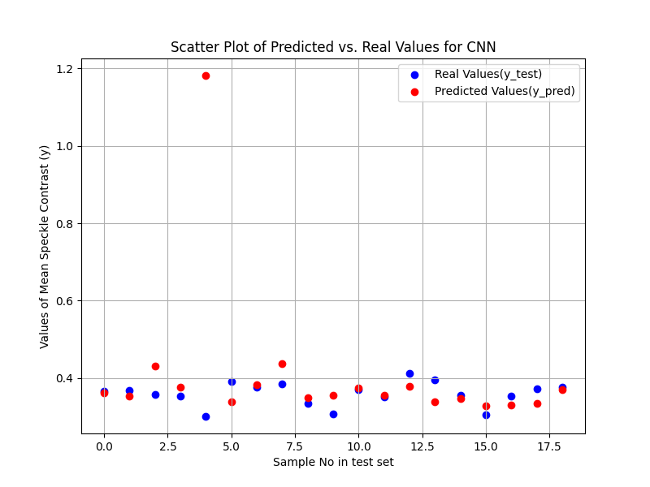

Figure C2 set1

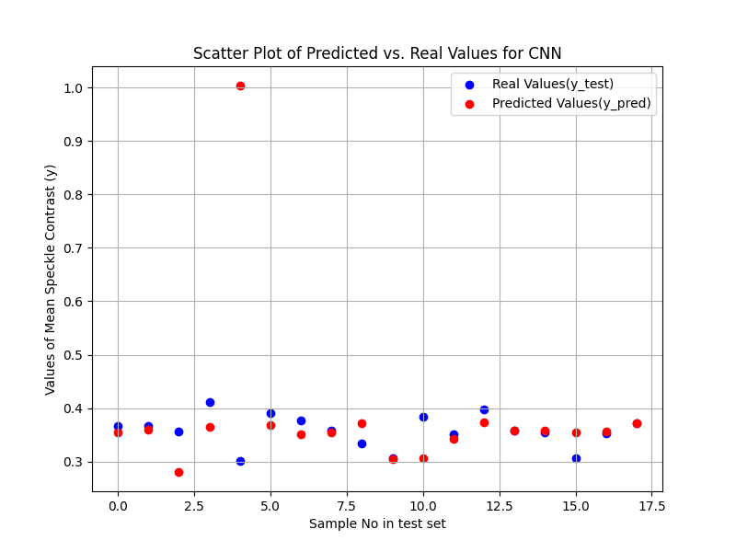

Figure C2 set3

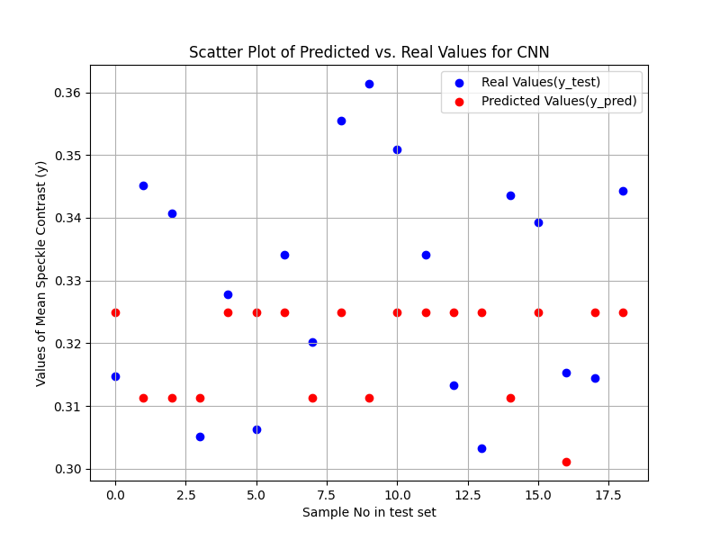

Figure C3 Set1

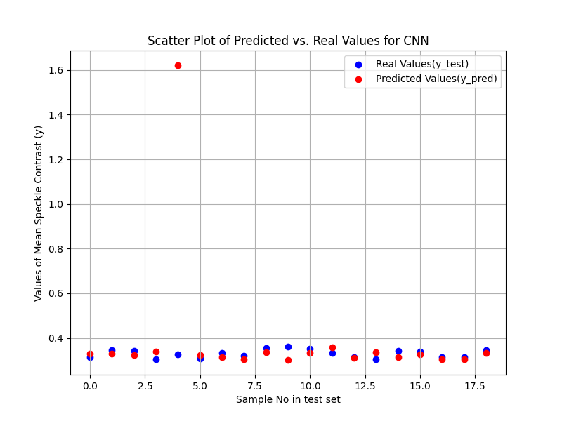

Figure C3 set3

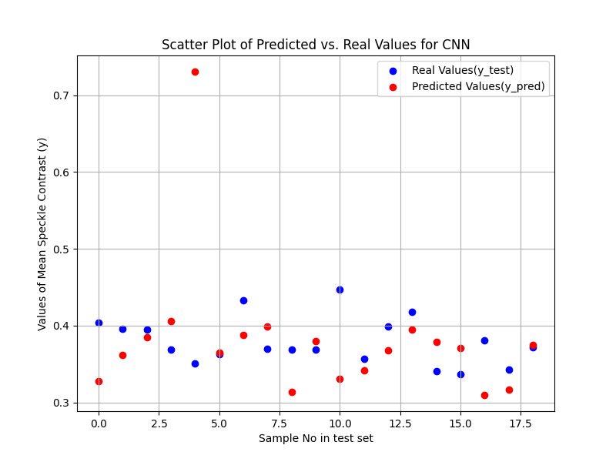

Figure C4 set1

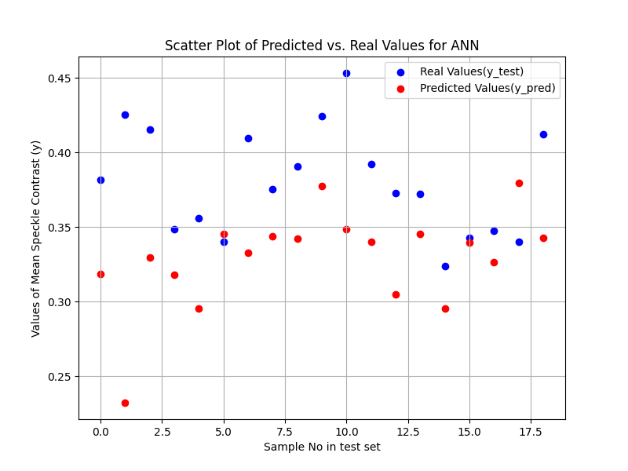

Figure C4 set3

#### Additional Scatter Plot with Regression fit Results for Corner speckle images: The figure contains the performance metrics like MSE (Mean squared Error) along with MAE (Mean Absolute error).

#### 

Figure C1 set1

#### 

Figure C1 set3

#### 

Figure C2 set1

#### 

Figure C2 set3

#### 

Figure C3 set1

#### 

Figure C3 set3

#### 

Figure C4 set1

#### 

Figure C4 set3

#### 3-D Convolutional Neural Network (3D CNN)

3D Convolutional Neural Network (3D-CNN) for tasks like volumetric data classification or temporal sequence analysis for Image regression. The 3D-CNN model processes three-dimensional input data to capture spatial and temporal features effectively. Grayscale speckle images were resized to a fixed dimension of width x height pixels and normalized by scaling pixel values to the range [0,1]. The images were reshaped to include a single channel, forming an input tensor with the shape (samples, width, height, channel). For Greyscale, channel is 1.

**Methodology**:

**1.** **Input Layer**: The input to the model is a three-dimensional tensor, representing volumetric data or frames stacked over time. This layer normalizes the input data to ensure stability during training.

**2.** **Convolutional Layers (Conv3D)**:

* These layers extract spatial and temporal features using 3D filters.
* Each filter moves across the 3D input, performing convolutions to detect patterns in both spatial and temporal dimensions.
* Activation Function: **ReLU (Rectified Linear Unit)** is applied after each convolution to introduce non-linearity.

**3. Pooling Layers (MaxPooling3D):**

* MaxPooling3D layers reduce the spatial dimensions, retaining only the most significant features while minimizing computational complexity.
* These layers prevent overfitting and make the model more efficient by reducing parameters.

**4.** **Flatten Layer**:

* The 3D feature maps are flattened into a one-dimensional vector, preparing them for fully connected layers.

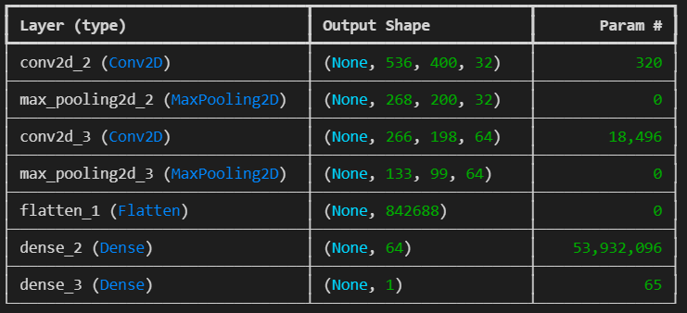

Figure Work flow of 3-D CNN for a C4 set 3 Center

**5.** **Fully Connected Layer**:

* This dense layer maps the extracted features to the output classes or predictions.
* It serves as the final stage where all high-level information is integrated.

**6.** **Output Layer**: Activation Function: **Linear** is used for predicting a single continuous value for each sample (Xi’s).

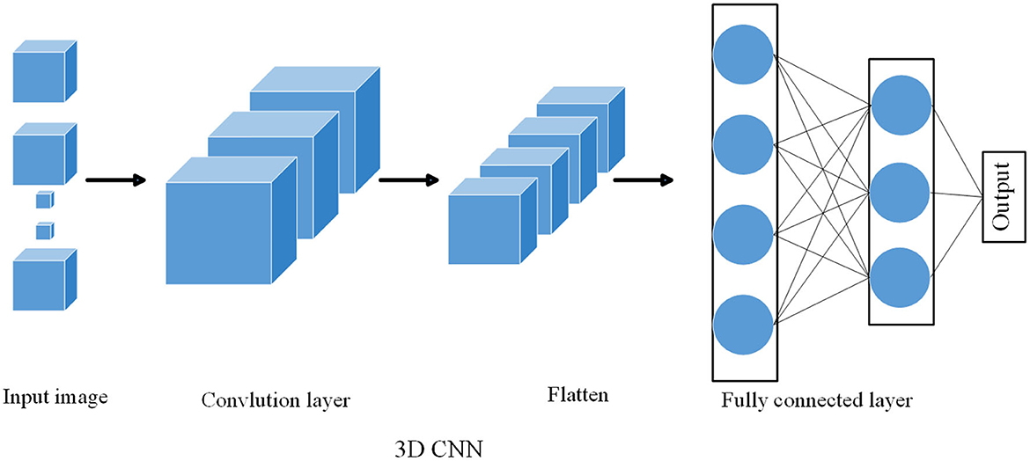

**Figure 40:** Visual representation of fully connected 3-D CNN for Image regression. (<https://www.frontiersin.org/journals/neurorobotics/articles/10.3389/fnbot.2023.1285673/full>)

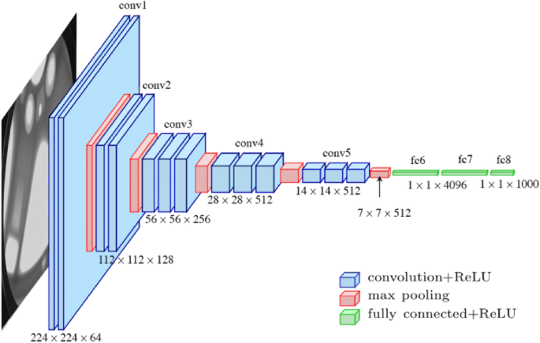

**Figure 41:** Representation of Process going inside the dense and hidden layers in Fully connected 3-D CNN (<https://medium.com/aiguys/efficient-nets-scaling-of-conv-networks-6ffa0e102fc7>)

The below table shows the dimensions of Center and Corner speckle images after resizing and removing the extra padded area across the borders that do not contribute to the predictions of the Yi’s.

|  |  |
| --- | --- |
| **Table 2: Center Speckle Images** | |
| **Experimental Set at particular Concentration.** | **Resized Dimensions (width x height) in pixels** |
| C1 set 1 | 918 x 689 |
| C1set 2 | 915 x 689 |
| C2 set 1 | 918 x 689 |
| C2 set 3 | 838 x 629 |
| C3 set1 | 1095 x 821 |
| C3 set 3 | 538 x 404 |
| C4 set 1 | 836 x 629 |
| C4 set 3 | 538 x 402 |

|  |  |
| --- | --- |
| **Table 3: Corner Speckle Images** | |
| **Experimental Set at particular Concentration.** | **Resized Dimensions (width x height) in pixels** |
| C1 set 1 | 915 x 689 |
| C1set 3 | 755 x 558 |
| C2 set 1 | 918 x 689 |
| C2 set 3 | 755 x 565 |
| C3 set1 | 795 x 595 |
| C3 set 3 | 918 x 689 |
| C4 set 1 | 806 x 602 |
| C4 set 3 | 924 x 689 |

#### Note: In the above tables, dimensions of some sets of images were absent, instead their pixel information are provided in the form of xlsc format. These pixels information contributes in initial labelling and calculation of Yi’s in FIJI software.

#### Results and plots for 3-D CNN:

#### The results of 3-D CNN are presented below by the Scatter plots for Actual vs Predicted values for every set of input images as mentioned in the second and third tables. (i.e. 8 sets for corner and center)

#### Scatter Plot Results for Center speckle images: If the red and blue dot coincides, then it represents that, predicted value of mean speckle contrast (Yi pred) for the image in the test set is equal to its actual value (Yi).

#### 

Figure C1 set1

#### 

Figure C1 set3

#### 

Figure C2 set1

#### 

Figure C2 set3

#### 

Figure C3 set1

#### 

Figure C3 set3

#### 

Figure C4 set1

#### 

Figure C4 set3

#### Scatter Plot Results for Corner speckle images:

#### 

Figure C1 set1

#### 

Figure C1 set3

#### 

Figure C2 set1

#### 

Figure C2 set3

#### 

Figure C3 set1

#### 

Figure C3 set3

#### 

Figure C4 set1

#### 

Figure C4 set3

#### Results:

By comparing and visualizing the results of ANN and 3-D CNN, we can say that ANN with FFT as feature extraction is more efficient in predicting the mean speckle contrast values at every set of corner and centre speckle images when compared to 3-D CNN image regression.

**1. ANN + GridSearchCV:**

* **Model Performance**:
  1. Optimized using Grid Search CV with cross-validation.
  2. Hyperparameters such as the number of neurons, batch size, epochs, and learning rate were fine-tuned.
  3. The best configuration achieved stable accuracy on the validation dataset.
  4. ANN models are easier to train and tune for smaller datasets, but their performance drops when dealing with unstructured or high-dimensional data.
* **Validation Accuracy**: High accuracy with a well-tuned model, demonstrating that the ANN is capable of handling the problem effectively.
* **Training Behaviour**: Smooth convergence of loss and accuracy, indicating proper model optimization.
* **Key Observations**: ANN performed well for the structured dataset, but further generalization could be limited for complex or high-dimensional data.

**2. 3D-CNN:**

* **Model Performance**:
  1. Designed for processing 3D input data (e.g., volumetric or temporal sequences).
  2. Achieved excellent accuracy on the test dataset, showcasing the power of CNNs in capturing spatial-temporal features.
  3. 3D-CNNs handle larger, more complex datasets effectively but at the cost of increased computational requirements.
* **Validation Accuracy**: Higher validation accuracy than ANN, especially for 3D datasets requiring feature extraction from spatial or temporal dimensions.
* **Training Behaviour**:
  1. Faster convergence due to Conv3D layers efficiently extracting features.
  2. Minor overfitting was observed but mitigated through dropout layers.
* **Key Observations**: The model is highly effective for high-dimensional data but requires significant computational resources.

Additionally, there is a popular library in ML known as Lazy Predict (Lazy regressor). Lazy Predict helps build a lot of basic models without much code and helps understand which models work better without any parameter tuning. It is a simple and efficient tool that makes your predictive modelling projects easier and faster. Below are the attached results of lazy prediction when it is implemented over centre and corner images. These results are in tabular form, representing the list of ML models, including their metrics, which are attached here. Also, the reference results are given below for C1 set 1 center.

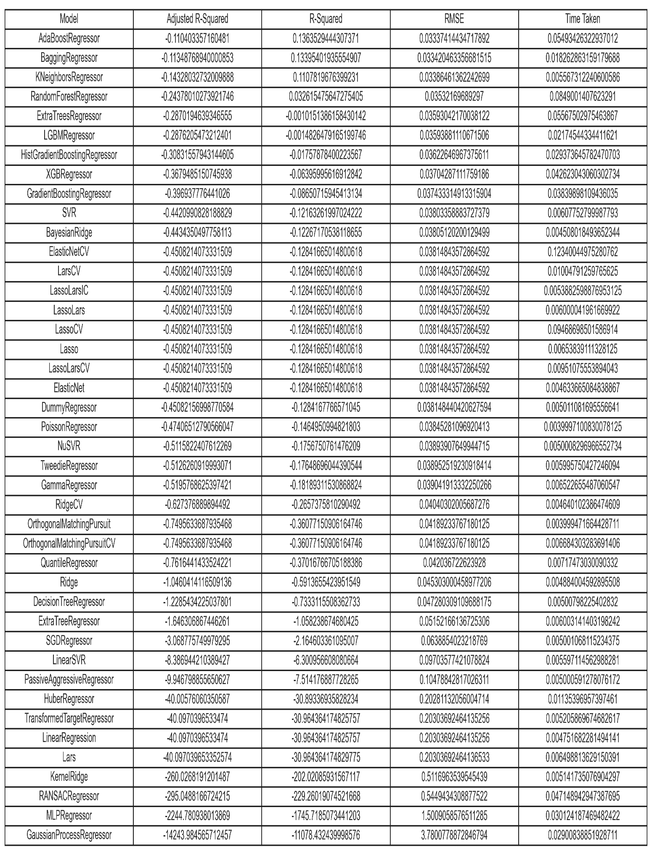

### Conclusion

In conclusion, this study demonstrated the viability of using machine learning models to predict mean contrast values DLSI images of nematode suspension. The results of this study show that machine learning models, particularly ANN, can provide accurate predictions of particle dynamics and their motility as captured by mean contrast values from DLSI images. As MSE and MAE for ANN is less when compared to 3-D CNN. By combining Fast Fourier transform preprocessing with regression models, we gained insights into motility, health, and response to acidic treatments varying with concentrations. The ANN model offered the best performance, showcasing the potential for these models to be applied in biological monitoring systems. Future work could extend the dataset to include more complex biological systems and refine the models for real-time analysis.

# References

# Quillen, A. C., Peshkov, A., Wright, E., & McGaffigan, S. (2021). Metachronal waves in concentrations of swimming Turbatrix aceti nematodes and an oscillator chain model for their coordinated motions. Physical Review E, 104(1), 014412.

# Zhou, K., Zhou, C., Sapre, A., Pavlock, J. H., Weaver, A., Muralidharan, R., ... & Ebrahimi, A. (2020). Dynamic laser speckle imaging meets machine learning to enable rapid antibacterial susceptibility testing (DyRAST). ACS sensors, 5(10), 3140-3149.Dainty, J. C. (Ed.). (2013).

# Laser speckle and related phenomena (Vol. 9). Springer science & business Media.

# The Scientist and Engineer’s Guide to Digital Signal Processing – Steven W.smith,

# Hultman, M., Larsson, M., Strömberg, T., & Fredriksson, I. (2020). Real-time video-rate perfusion imaging using multi-exposure laser speckle contrast imaging and machine learning. Journal of Biomedical Optics, 25(11), 116007-116007.

# Hao, X., Wu, S., Lin, L., Chen, Y., Morgan, S. P., & Sun, S. (2022, October). Can Laser Speckle Contrast Imaging be a quantitative measurement using machine learning?. In 2022 2nd International Conference on Electronic Information Engineering and Computer Technology (EIECT) (pp. 355-363). IEEE.

# Chen, Y., Han, W., Bin, G., Wu, S., Morgan, S. P., & Sun, S. (2024). Quantum machine learning enhanced laser speckle analysis for precise speed prediction. *Scientific Reports*, *14*(1), 27665.

# Shen, M., Sheyfer, D., Loeffler, T. D., Sankaranarayanan, S. K., Stephenson, G. B., Chan, M. K., & Morgan, D. (2023). Machine learning for interpreting coherent X-ray speckle patterns. *Computational Materials Science*, *230*, 112500.

# Zhou, Z., Joshi, C., Liu, R., Norton, M. M., Lemma, L., Dogic, Z., ... & Hong, P. (2021). Machine learning forecasting of active nematics. Soft matter, 17(3), 738-747.